***Business Reason***

Divisions have specific max and mins for the intial and renewal terms.

***Task Requirements***

Use the Div_Term_Exceptions data table to set the contract/renewal term drop down list.

***Build Plan***

Build

1. Attributes
   1. initialTerm_quote (Initial Term (Months))
   2. renewalTerm_quote (ExtRenewal Term (Months))
2. Set Defaults
   1. initialTerm_quote default is based on initialDefault column of Div_Term_Exceptions where division matches division_RO_quote
      1. change default of attribute to a function
      2. Code

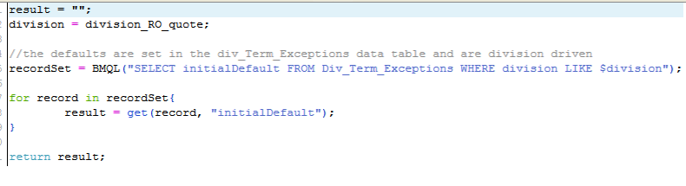

* 1. renewalTerm_quote default is based on renewalDefault column of Div_Term_Exceptions where division matches division_RO_quote
     1. follow same process as above

1. Set available values with quote level constraint rules
   1. Initial Term
      1. Current constrain rules. *The current constraint rules match all of the conditions in the data table except division 3812 which does not seem to exist on the site.*
         1. Constrain Term above 36 based on lawson division
            1. Divisions: 3105, 3112, 3152, 3153, 3157, 3160, 3161, 3168, 3170, 3186, 3280, 3421, 3434, 3436, 3439, 3616, 3620, 3703, 3811, 3812, 3840, 4058, 4066, 4069, 4071, 4079, 4271, 4323, 4411, 4473, 4523, 4538, 4717, 4742, 4800, 4832, 4833, 4840, 4841, 4843, 4847, 4852, 4853, 4855, 4859, 4862, 4863, 4939, 4975
         2. Constrain all except MTM for Temporay AccountType
         3. Existing Terms Constraint
         4. Constrain Term above 48 based on lawson division
            1. Divisions: 3133, 3302
         5. Constrain Term below 12 based on lawson division
            1. Divisions: 3607, 3614, 3639
   2. Renewal Term
      1. Current constraints. *The current constraint rules match all of the conditions in the data table except division 3812 which does not seem to exist on the site.*
         1. Constrain term above 36 based on Lawson division
            1. Division: 3105, 3112, 3152, 3153, 3157, 3160, 3161, 3168, 3170, 3186, 3280, 3421, 3434, 3436, 3439, 3616, 3620, 3703, 3811, 3812, 3840, 4058, 4066, 4069, 4071, 4079, 4271, 4323, 4411, 4473, 4523, 4538, 4717, 4742, 4800, 4832, 4833, 4840, 4841, 4843, 4847, 4852, 4853, 4855, 4859, 4862, 4863, 4939, 4975
         2. Constrain renewal term based on initial term
         3. Constrain all except MTM for Temporary AccountType
         4. Existing Terms Constraint
         5. Constrain Term above 48 based on lawson division
            1. Divisions: 3133, 3302
         6. Constrain term below 12 based on Lawson division
            1. Divisions: 3607, 3614, 3639
         7. Constrain renewal allow MTM only
            1. Divisions: 3250, 3272, 3280
            2. Step must be adjustPricing

Unit Test

1. For Division 4862, see quote A147477.
   1. Works fine. Only items under 36 are shown.

***Admin Guide Changes***

None. Nothing was added.

***User Guide Changes***

None.